Analysis and Experiments on the Impact of Frequency Nonlinearity on Displacement Motion Sensing with FMCW Radar

Zhiwei Zhang, *Graduate Student Member, IEEE*, Jingtao Liu, *Graduate Student Member, IEEE*, Jiayu Zhang, *Graduate Student Member, IEEE*, Changzhan Gu, *Senior Member, IEEE*

[1]

***Abstract*—Frequency-modulated continuous wave (FMCW) radar has been widely adopted for motion sensing applications due to its superior resolution and accuracy. However, the inherent nonlinear errors may significantly degrade its performance. To the best of our knowledge, the impact of nonlinear frequency modulation (NLFM) on displacement motion sensing has not been studied. This paper presents the first comprehensive investigation into the influence of NLFM on displacement motion sensing, supported by theoretical derivations, simulation analysis, and experimental validations. Additionally, the linearity requirements for accurate motion sensing are analyzed and verified, providing theoretical guidance for displacement motion sensing applications. Further, an open-loop FMCW radar architecture is validated to achieve precise displacement motion detection with reduced hardware complexity. Comparative experiments demonstrate that the validated architecture, with hardware complexity comparable to that of an open-loop CW radar, achieves sensing performance similar to that of closed-loop FMCW radar, with an accuracy difference of less than 1.6%, which makes it particularly suitable for low-cost, low-complexity, high-accuracy, and miniaturized short-range radar motion sensing applications. The miniaturized radar, based on the validated architecture, successfully reconstructs differential microwave cardiograms (D-MCG) that exhibit high consistency with electrocardiograms (ECG), demonstrating the architecture's significant advantages in practical applications.**

***Index Terms*—Displacement motion sensing, frequency-modulated continuous wave (FMCW) radar, nonlinear frequency modulation, open-loop FMCW architecture, radar** **architecture.**

# I. INTRODUCTION

I

N recent years, frequency-modulated continuous wave (FMCW) radar has been widely used in short-range sensing applications, such as health monitoring [1], [2] [3], vibration detection [4], [5], and gesture recognition [6], [7], thanks to its simple architecture, low cost, and superior accuracy and sensitivity in displacement motion sensing. The FMCW radar significantly reduces hardware complexity by mixing the linearly frequency-modulated signal from the local oscillator (LO) with the received signal to generate the beat signal, while maintaining high accuracy and sensitivity. However, the nonlinear frequency modulation (NLFM) typical in FMCW radar sensors leads to a decrease in the main lobe amplitude and spectral broadening of the beat signal [8]. Then, the target information detected by the radar becomes susceptible to interference from clutters around, which adversely degrades its sensing performance.

Despite the widespread application and high sensitivity of FMCW radar in displacement motion sensing, existing research on the impact of NLFM on FMCW radar primarily focuses on range sensing, with little attention given to displacement motion sensing. In [9], a sinusoidal signal model was introduced to characterize NLFM in homodyne FMCW radar, along with a theoretical framework that quantitatively relates NLFM to range resolution. The study further analyzes the effects of both the amplitude and frequency of sinusoidal NLFM on resolution degradation. In [10], NLFM in FMCW/FSCW radar systems is modeled using a multisine phase signal (MPS), and it is demonstrated that NLFM induces frequency shifts in the beat signal, substantially degrading range estimation accuracy. In [11], a polynomial approximation (PPS) model is proposed for NLFM. Based on this PPS model, a time resampling method is proposed to linearize the spectrum of the beat signal. In [12], it is shown that NLFM-induced degradation of range resolution is distance-dependent, becoming increasingly severe at longer target ranges. Additionally, Gu et al. [13] present a range-dependent error model that quantifies the impact of NLFM on both range accuracy and resolution in LFMCW radars.

Over the past few decades, many nonlinear correction techniques for FMCW radar have been developed by both hardware-based and software-based approaches. The most widely used hardware solution involves a phase-locked loop (PLL) to form a closed-loop architecture to generate linear frequency-modulated signals [14], [15], and [16]. But this technique requires additional components, such as the PLL, loop filters, reference clock and control circuitry, increasing system complexity, physical size, power consumption, and overall cost. In [11], [17] and [18], direct digital synthesizers (DDS) are used to generate linear frequency-modulated waveforms. However, DDS architectures are fundamentally constrained by Nyquist limitations, making it difficult to support the wideband chirp generation required in modern FMCW systems. In [19], and [20], nonlinear frequency-modulated signals are corrected using closed-loop systems based on analog and digital compensation circuits, respectively. But both approaches involve intricate circuit designs and calibration procedures, which significantly complicate system integration and increase design effort, thereby limiting their practical applicability in compact or low-cost radar applications.

Software-based methods for correcting NLFM generally predict the coefficient of the nonlinear modulation model and apply calibration to beat signals in the digital domain. [11] proposed a time resampling technique to correct the spectrum of the beat signal under NLFM. However, this method requires prior knowledge of the nonlinear modulation model coefficients. In [12], a residual video phase (RVP) filter is employed to remove the range-dependent effect of NLFM, enabling calibration even for long-range detection. However, this approach requires a reference nonlinear frequency response to estimate the nonlinear function. In [21], a high-order ambiguity function (HAF) is used to estimate the polynomial phase coefficients of the NLFM model from the reference target’s beat signal. However, this method also requires an accurate reference target signal. If the reference target's reflection is too weak or multiple targets are too close, the estimation of nonlinear coefficients may be inaccurate. Similar techniques, such as the multisynchrosqueezing transform (MSST) [22], the improved HAF with the complementary ensemble empirical mode decomposition (CEEMD) [23], and the variational nonlinear chirp mode decomposition (VNCMD) [24], are used to estimate the NLFM model coefficients based on the reference beat signal. Subsequently, a time resampling method is employed to compensate the beat signal under NLFM. These software-based methods, as described, rely on the reference signals, which adds to the design complexity and the challenges in practical application. In [25], a reference-free calibration method is proposed, where the voltage-controlled oscillator (VCO) output radio frequency (RF) signal is directly sampled to obtain the time-frequency representation of the VCO's response. The polynomial NLFM model coefficients are estimated, and the beat signal is then calibrated using time resampling. However, this method requires direct sampling of the RF signal, necessitating an extremely high sampling rate.

Overall, current research on NLFM in FMCW radar faces two main challenges: First, the impact of NLFM on displacement motion sensing is still unclear, and second, existing linearity correction techniques, whether hardware-based or software-based, are constrained by high cost and complexity. Although [26] proposes a low-complexity, reference-free VCO nonlinear compensation method that focuses on improving range resolution, it does not provide a detailed analysis or experimental validation of the method's impact on displacement motion sensing. To address these issues, this paper thoroughly investigates the impact of NLFM on displacement motion sensing in FMCW radar. Building on the theoretical analysis, we extend the nonlinear compensation method in [26] for range resolution enhancement to displacement motion sensing. The contributions of this paper are summarized as follows:

1) For the first time, the impact of NLFM on displacement motion sensing in FMCW radar is systematically analyzed through detailed theoretical derivation and validation. Furthermore, it is demonstrated that displacement motion sensing exhibits good robustness to NLFM.

2) Based on the theoretical analysis, this work explicitly defines the linearity requirements for accurate displacement motion sensing and validates the requirements through simulations and experiments, offering key theoretical guidance for FMCW radar applications.

3) Building on the theoretical analysis, we extend the nonlinear compensation method in [26] to displacement motion sensing. Through experiments, we demonstrate that this method outperforms common radar, and exhibits strong robustness against temperature and supply voltage variations.

4) This paper provides the first systematic comparison of common CW, FMCW, and validated FMCW radar architectures for displacement motion sensing

# II. Theoretical Analysis and Methodology

## A. Nonlinear Frequency Modulation Signal Model

In an FMCW radar system, the RF signal generated by the VCO is split into two paths. One path is transmitted via the antenna, while the other is used as the LO signal for the mixer, as in Fig. 1(a).



where *φ*(*t*) represents the instantaneous phase of the transmitted signal, which is given by



*fT*(*t*) is the instantaneous frequency. Under ideal conditions, *fT*(*t*) follows a LFM model, given by *fT*(*t*) = *f0* + *γt*, where *f0* denotes the initial modulation frequency, *γ* represents the LFM coefficient, and *γ = B/T*, *B* represents the modulation bandwidth of the chirp signal, *T* denotes the ramp-up time. Considering VCO nonlinearity, the instantaneous frequency of the transmitted signal can be modeled as



where Δ*f*(*t*) characterizes the nonlinear frequency deviation. The instantaneous frequency of the FMCW radar transmitted signal under both LFM and NLFM is illustrated in Fig. 1(b-1). The Linearity is defined as [26]



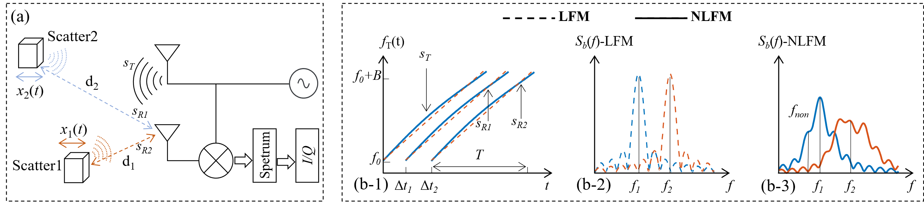

**Fig. 1.** FMCW radar signals under linear (LFM) and nonlinear frequency modulation (NLFM): (a) simplified block diagram of FMCW radar, (b-1) instantaneous frequency of transmitted and received signals under LFM and NLFM, (b-2) spectrum of beat signal under LFM, and (b-3) spectrum of beat signal under NLFM.

Substituting (2) and (3) into (1), the transmitted signal with NLFM can be expressed as



The transmitted signal is reflected by multiple scatterers and propagates into the receiver, forming the received signals, as shown in Fig. 1(a) and Fig. 1(b-1).



Here, *t* represents the fast time, and *τ* denotes the slow time. The number of scatterers is given by *K*, where *Ak* is the amplitude of the reflected signal from the *k*th scatterer. The round-trip delay time (RTDT) is expressed as Δ*tk*(*τ*) = 2*Rk*(*τ*)/*c* and *Rk*(*τ*) = *dk* + *xk*(*τ*), where *c* is the speed of light, *dk* represents the nominal distance between the radar and the *k*th scatterer, and *xk*(*τ*) denotes its displacement.

After mixing the LO signal and received signals, the resulting beat signals can be formulated as



where ∗ indicates the complex conjugate operation, and $γΔt_{k}^{2}\left(τ\right)$ corresponds to the RVP term, which is considered negligible in short-range radar applications [28].

In FMCW radar, NLFM can be represented as a linear combination of multisine signals [10]. Consequently, the characteristics of NLFM can be effectively analyzed by examining a single sinusoidal modulation signal. To facilitate theoretical derivation, a sinusoidal function is adopted in this work as a representative model for NLFM, so



where *β* and *fnon* refer to the amplitude and frequency of the sinusoidal NLFM, respectively. In short-range FMCW radar applications, Δ*tk*(*τ*) typically ranges between 10-9 and 10-8 s. Therefore,



Substituting (8) and (9) into (7), the beat signals are written as



Utilizing the mathematical properties of Bessel functions of the first kind *Jn*(·), the nonlinear modulation term in the beat signals can be expanded into a series representation as



Based on the properties of *Jn*(·) and the condition $x_{k}\left(τ\right)≪d_{k},$ it follows that *Jn*(4*πβRk*(*τ*)/*c*) ≈ *Jn*(4*πβdk*/*c*). Therefore, the beat signal can be expressed as



Taking the Fourier transform along the fast-time dimension, the spectrum of the beat signals can be formulated as



where sinc(*x*) = sin(*πx*)/*πx*, *fk* = 2*γRk*(*τ*)/*c* is the beat frequency of the *k*th scatterer. As in (13), sinusoidal NLFM introduces pronounced sidelobes around the beat frequency of the scatterer, leading to significant spectral broadening of the beat signal, as compared in Fig. 1(b-2) and Fig. 1(b-3).

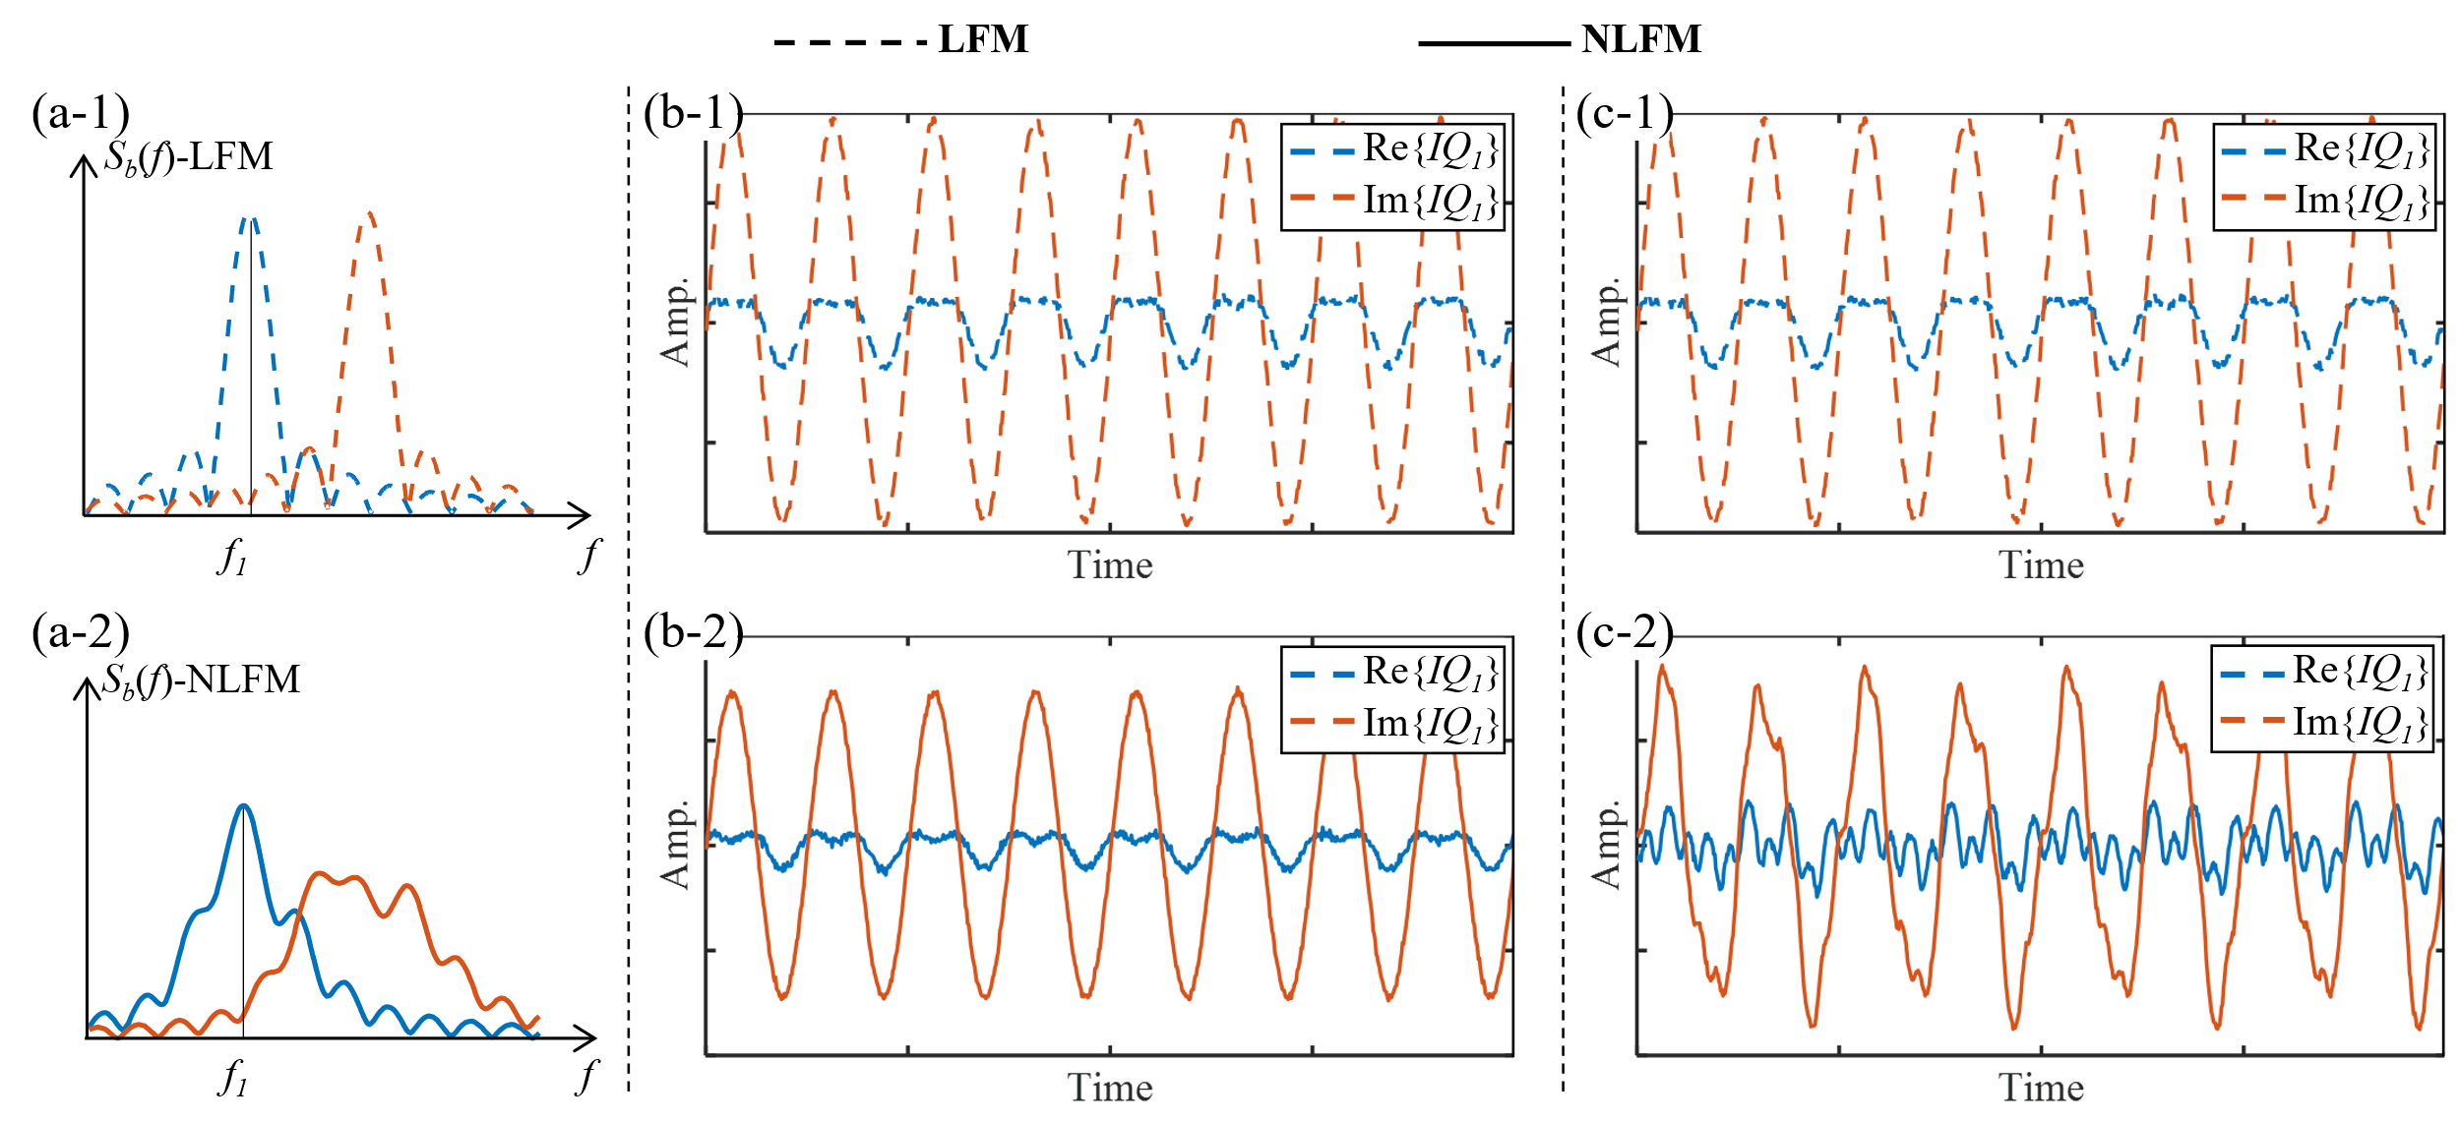

**Fig. 2.** Impact of NLFM on FMCW radar displacement motion sensing: (a) spectrum of the beat signal, (b) extracted target *I/Q* signal in the “*Moving Target with Stationary Scatterers*” scenario, and (c) extracted target *I/Q* signal in the “*Multiple Moving Scatterers Coexist*” scenario. In each column: (1) is the results under LFM; (2) is the results under NLFM.

Building upon the preceding analysis, this study has comprehensively extracted the full spectral characteristics of the beat signal under NLFM, encompassing both frequency and phase information.

## B. Impact on Displacement Motion Sensing

In displacement motion sensing, it is essential to extract the quadrature signal corresponding to the target’s beat frequency from the beat signal spectrum along the slow-time dimension [29]. Suppose the first scatterer represents the target of interest for motion demodulation, then its quadrature *I/Q* signal can be extracted at the beat frequency of the first scatterer, leading to



where *n*(*τ*) denotes the noise, which follows a Gaussian distribution with a mean of zero and a variance of *σ*2. Due to the influence of sinusoidal NLFM, *Bk* cannot be approximated as zero as in the LFM case. Consequently, the extracted target *I/Q* signal unavoidably includes coupled signals from other scatterers, which may degrade motion sensing accuracy and, in extreme cases, lead to sensing failure.

Radar-based displacement motion sensing scenarios can be categorized into two types: One scenario, named “*Moving Target with Stationary Scatterers*”, involves a single moving target with stationary scatterers. The other scenario, named “*Multiple Moving Scatterers Coexist*”, includes multiple moving scatterers in addition to the target. To thoroughly investigate the impact of NLFM on displacement motion sensing, detailed theoretical analysis will be conducted for each scenario.

*1) Moving Target with Stationary Scatterers:* In this scenario, all scatterers except for the target remain stationary, which implies that *xk*(*t*) = 0, *k*≥2. Therefore, the extracted target *I/Q* signal is given by



The coupled signals from other scatterers primarily introduce an increased DC component in the target *I/Q* signal, which can be easily eliminated using the circle fitting method [30]. After DC calibration, the motion information of the target can be conveniently recovered from the *I/Q* signal using phase demodulation methods such as MDACM [31].

Subsequently, the amplitude *B1* of the target *I/Q* signal is analyzed. As shown in (14), the amplitude *B1* consists of two components: one originating from the main lobe, while the other results from spectral leakage of the sidelobes. Due to the attenuation characteristics of the *sinc* function, the sidelobe leakage at the target beat frequency is significantly lower than the main lobe. Consequently, *B1* is predominantly determined by the main lobe and can thus be approximated as



Under ideal LFM conditions, *β* = 0, the amplitude of the target *I/Q* signal can be expressed as



Due to |*J*0(*x*)| < 1, *x* ≠ 0, NLFM results in a reduction in the amplitude of the target *I/Q* signal, leading to a decrease in its signal-to-noise ratio (SNR), as compared in Fig. 2(b). The SNR is given by *SNR* = $B_{1}^{2}/σ^{2}$. The degradation of SNR directly impacts the performance of target motion perception.

In typical application scenarios, when the SNR attenuation does not exceed 3 dB, i.e., the condition *SNRnonlinear* ≥ *SNRlinear/2* in value is satisfied, the impact of NLFM on displacement motion sensing is minimal. Hence



*J*0(*x*), is approximately equal to $\sqrt{2}/2$ when *x* = 1.126. Therefore, in this scenario, the amplitude *β* constraint of sinusoidal NLFM can be given as



The linearity constraint is formulated as



*2) Multiple Moving Scatterers Coexist:* When additional moving scatterers are present in the environment, the extracted *I/Q* signal of the target no longer satisfies the expression given in (15). Assuming that the second scatterer (*k* = 2) is the closest to the target and remains in motion (*x*2(*τ*) ≠ 0) while all other scatterers remain stationary, the extracted *I/Q* signal of the target in this scenario can be expressed as



Due to sinusoidal NLFM, *B*2is non-negligible, resulting in motion coupling from the second scatterer into the target’s *I/Q* signal, as shown in Fig. 2(c). This motion-induced interference introduces additional phase disturbances, which degrade the accuracy of circle fitting and phase demodulation, ultimately leading to demodulation failure.

The following discussion will delve into the constraint of linearity for accurate detection of the target’s motion. From (10), the instantaneous frequency *fb,k*(*t*) of the beat signal for the *k*th scatterer can be represented as



Assuming that the nominal distance between the target and the radar, *d*1, is smaller than that of the second scatterer, *d*2, the extracted target *I/Q* signal remains free of interference from the second scatterer if their spectra do not overlap, meaning



Based on (22), (23) can be rewritten as



Consequently, the linearity requirement for the “*Multiple Moving Scatterers Coexist*” scenario can be established.



As derived from (22), the beat signal of the *k*th scatterer has a spectral width of *BWk* = 8*πfnonβdk*(*τ*)/*c*, However, since the beat signal is only valid within the time interval [0, *T*], the truncation effect in the time domain introduces additional spectral broadening. After performing the Fourier transform, the final spectral width of the beat signal expands to *BWk,actual*=*BWk*+*BWwin*, where *BWwin* denotes the mainlobe width of the selected window function. Therefore, to ensure that the spectrum of the second scatterer does not overlap with *fb,*1(*t*), the following condition must be satisfied



Thus, accounting for time-domain truncation effects and window function selection, the constraints on the linearity of frequency modulation for the “*Multiple Moving Scatterers Coexist*” scenario can be formulated as

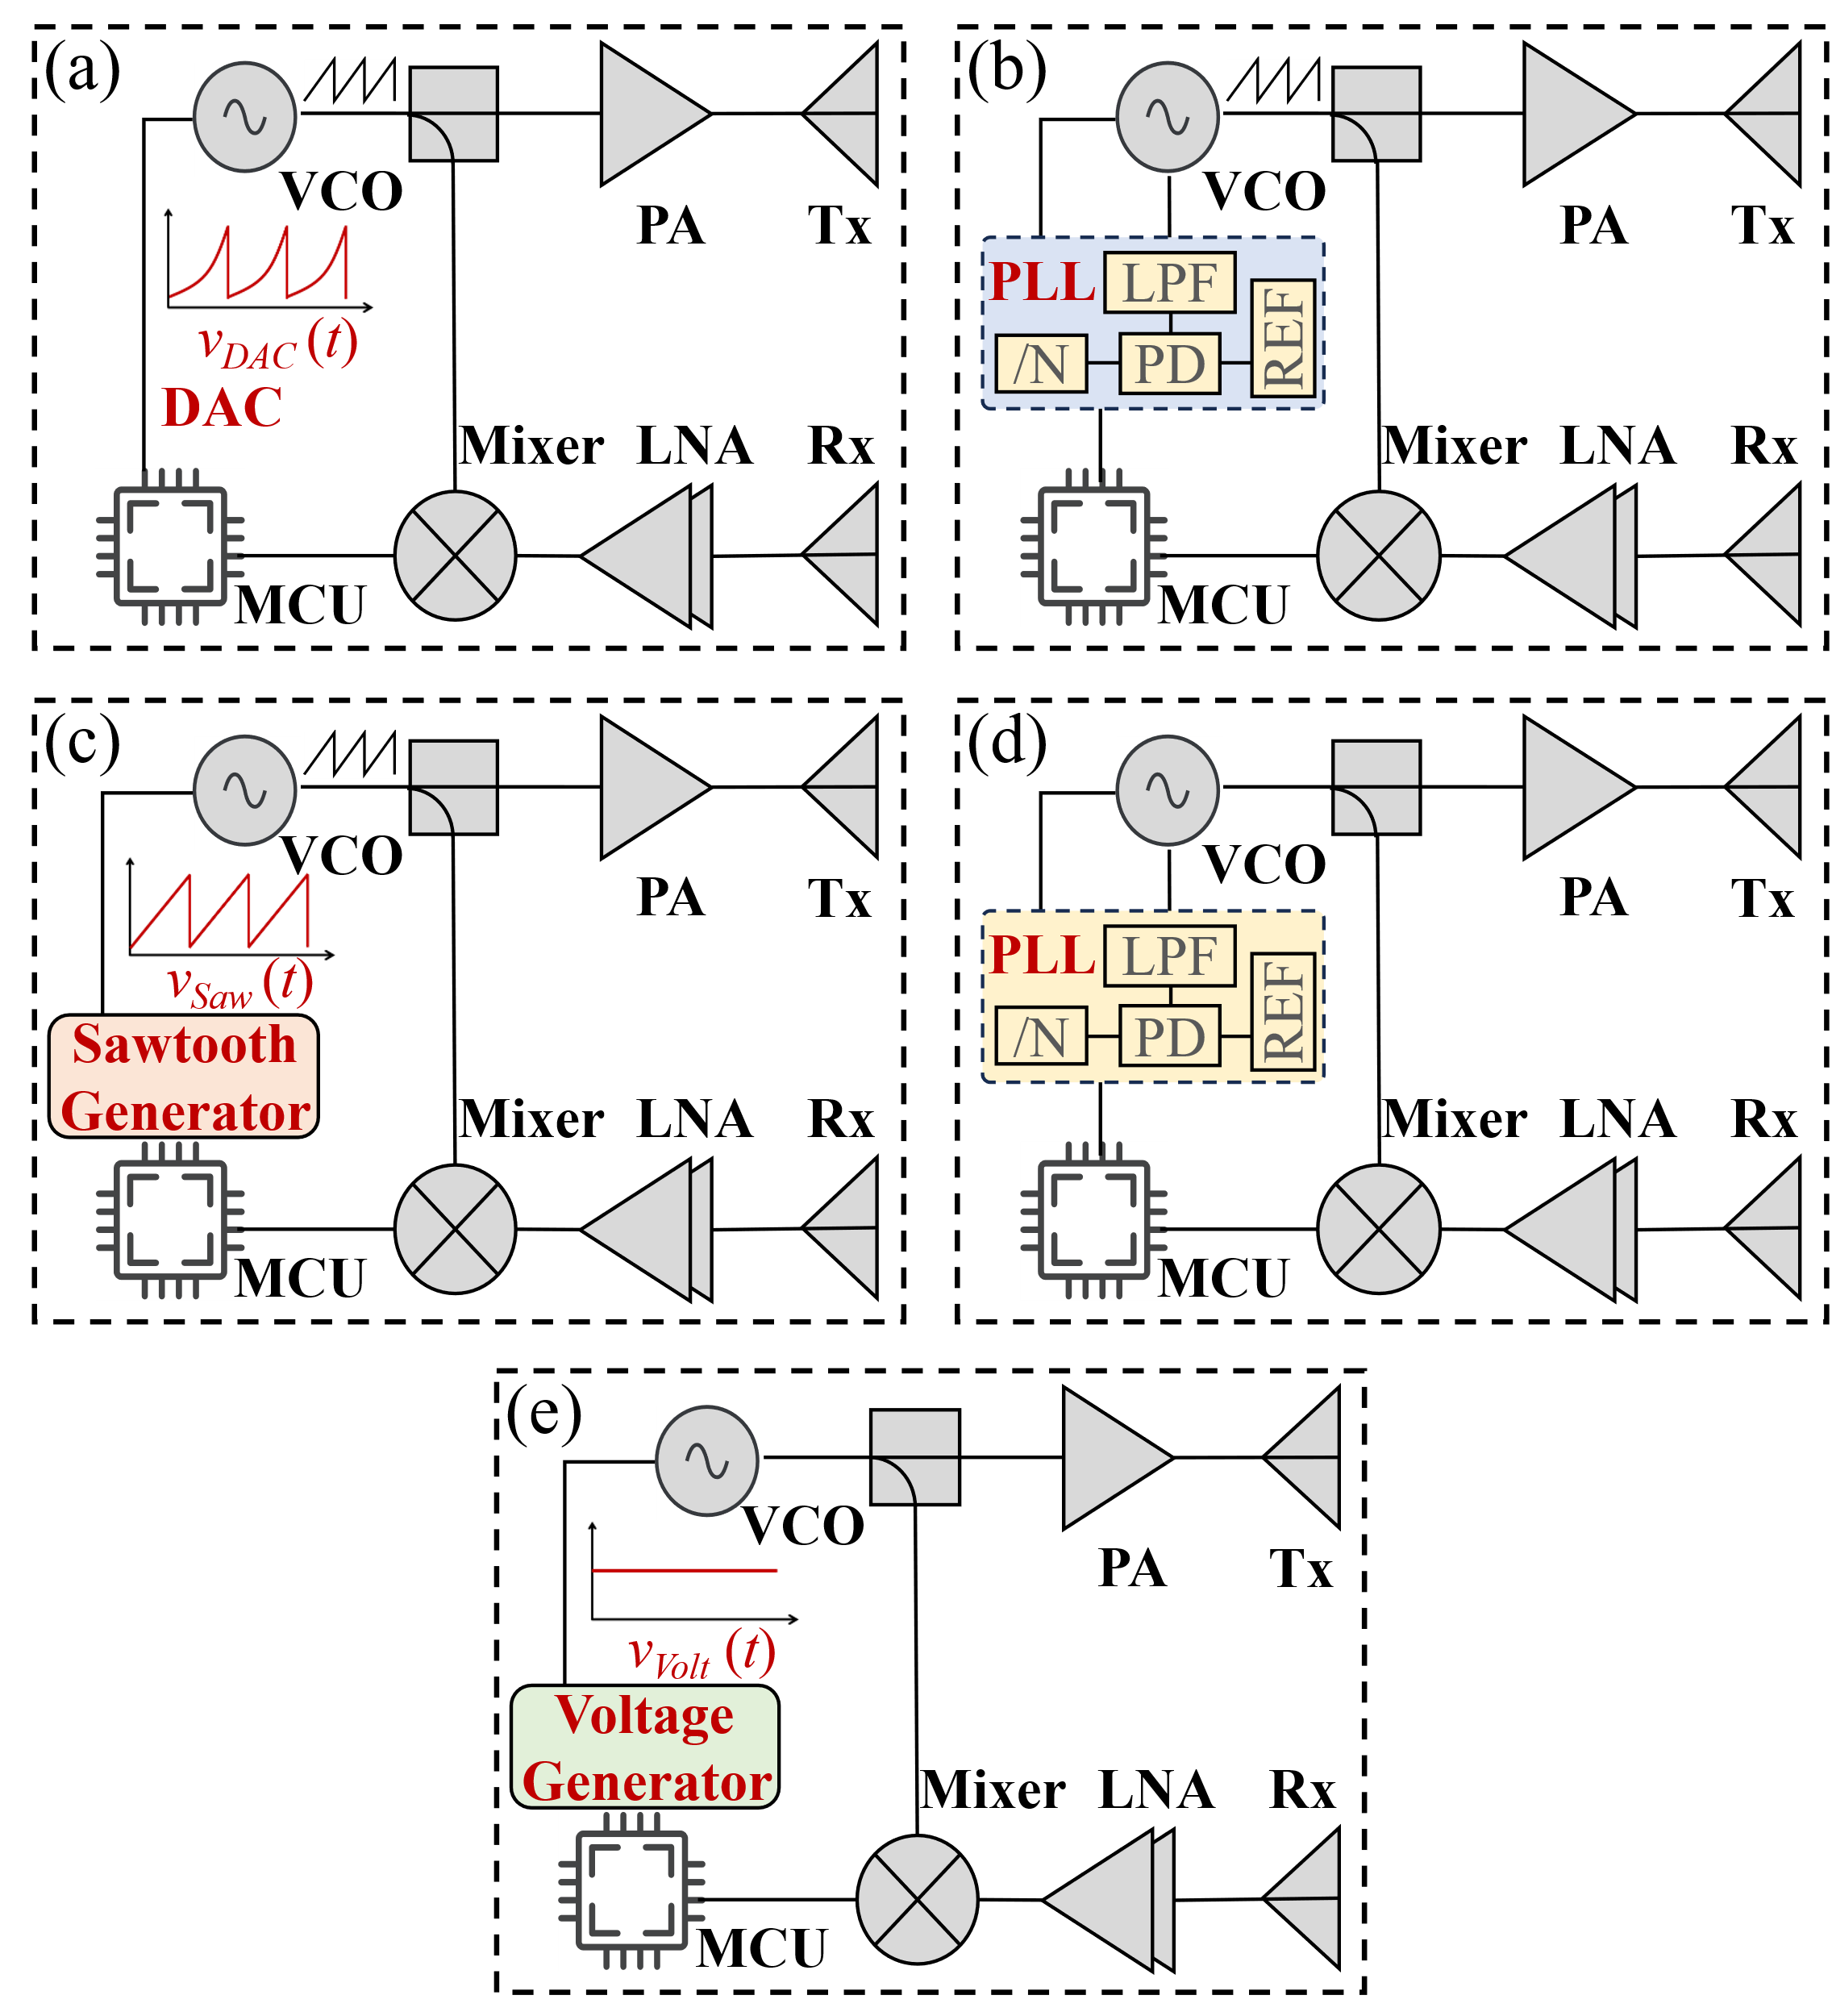

**Fig. 3.** Validated and common radar architectures: (a) validated FMCW, (b) the closed-loop FMCW with PLL (PLL-FMCW), (c) the open-loop FMCW with sawtooth waveform driven (Sawtooth-FMCW), (d) the closed-loop CW with PLL (PLL-CW), and (e) the open-loop external voltage-driven CW (Voltage-CW).



Although the time-domain truncation effect of the spectrum has been considered in the above analysis, the frequency of the beat signal varies continuously. Consequently, for a given frequency point of the beat signal, its duration is shorter than *T*. Therefore, the actual spectrum of the beat signal will be broader, and the linearity requirement should be slightly more stringent than that derived in (27).

Through the above analysis, this paper has conducted an in-depth study on the linearity requirements of frequency modulation for both motion sensing scenarios. The theoretical results from (20) and (27) indicate that the required modulation linearity is inversely proportional to the nominal target distance. The closer the target is to the radar, the lower the requirement for linear frequency modulation. Therefore, in short-range radar applications, displacement motion sensing demonstrates robustness to NLFM, achieving high-precision sensing without the strict reliance on ideal LFM. Guided by this conclusion, the next section presents a low-complexity open-loop FMCW radar architecture that enables precise motion sensing with reduced system cost and complexity.

## C. Low-Complexity Open-Loop Architecture

[26] introduces a nonlinear compensation method for enhancing range resolution. Based on the above theoretical analysis, displacement motion sensing shows good robustness to NLFM, making this method a highly appealing motion sensing architecture with low complexity. In this paper, we refer to it as the “open-loop FMCW radar architecture”, and draw it as shown in Fig. 3(a).

The open-loop FMCW radar architecture comprises a VCO, PA, low noise amplifier (LNA), mixer, a microcontroller unit (MCU) with an integrated digital-to-analog converter (DAC) and analog-to-digital converter (ADC), and a transmit-receive antenna system. In this architecture, the DAC directly drives the VCO to generate a linearly modulated chirp signal. After amplification by the PA, the signal is transmitted via an antenna. The echo signal received by the receiving antenna is amplified by the LNA, and mixed with the LO signal in the mixer, producing the beat signal, which is digitized by the ADC and processed by the MCU. Additionally, Fig. 3 also illustrates common radar architectures: the closed-loop FMCW radar architecture with a phase-locked loop (PLL-FMCW), the open-loop FMCW radar architecture with sawtooth waveform drive (Sawtooth-FMCW), the closed-loop CW radar architecture with PLL (PLL-CW), and the open-loop CW radar architecture with external voltage drive (Voltage-CW).

Unlike closed-loop FMCW radar as in Fig. 3(b), the VCO in the used architecture is driven directly by the DAC output. The required DAC voltage curve for LFM can be derived from the VCO's frequency-voltage (F-V) curve, *f* = Φ(*v*). Therefore,



This open-loop design eliminates the need for complex components, such as PLLs, loop filters and reference clock for PLL, which are typically used in traditional closed-loop FMCW radar systems. As a result, the radar system's hardware complexity, power consumption, and cost are significantly reduced. Based on the theoretical analysis in the previous section, displacement motion sensing exhibits a certain degree of robustness against NLFM. Therefore, even with temperature and supply voltage variations, this open-loop architecture may still achieve motion sensing accuracy similar to that of closed-loop FMCW radar systems.

# III. Numerical Simulation Validation

In this section, a comprehensive set of simulations is conducted to verify the theoretical analysis of NLFM on displacement motion sensing in FMCW radar, as established in Section II. Two scenarios are simulated, as detailed in Section II-B: “*Moving Target with Stationary Scatterers*” and “*Multiple Moving Scatterers Coexist*”.

In the subsequent simulations, the radar is configured with a ramp-up time of 10 ms, an initial modulation frequency of 120 GHz, an LFM coefficient of 80 GHz/s, a sinusoidal NLFM amplitude of *β*, and a sinusoidal NLFM frequency of *f*non. Therefore, the instantaneous frequency expression of the transmitted chirp signal is given by



where *f* is in GHz. The ADC sampling rate is set to 25,600 samples/s, and each chirp is sampled with 256 points. The Hamming window is widely used in FMCW radar multi-target motion sensing due to its effectiveness in suppressing spectral leakage. Therefore, in the simulations, all beat signals are processed using the Hamming window. Displacement demodulation follows the method described in [29].

## A. Moving Target with Stationary Scatterers

In this simulation, the target performs sinusoidal motion with an amplitude of 50 *µ*m (1/50 λ @ 120 GHz) and a frequency of 1 Hz at a nominal distance of *d*1 from the radar, while the closest scatterer keeps stationary at *d*2, *d*2 = *d*1 + 0.8 m. The beat signal amplitudes of the target and the scatterer are equal. All beat signals include additive Gaussian white noise, with the SNR set to 20 dB.

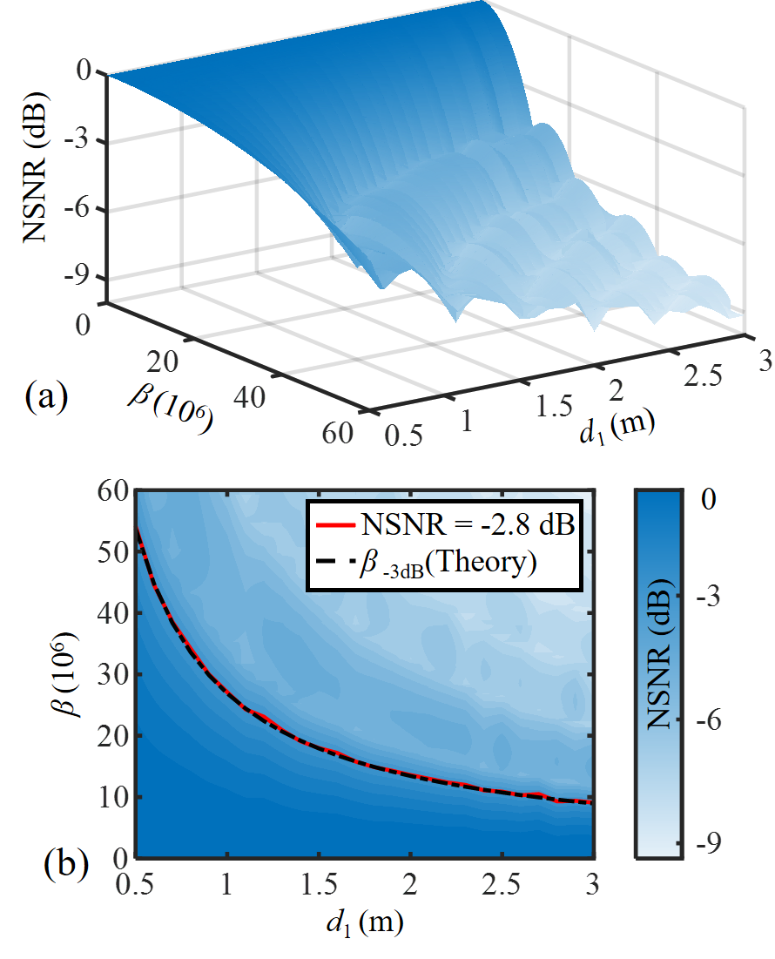

**Fig. 4.** Simulation validation for the “*Moving Target with Stationary Scatterers*” scenario: (a) simulated normalized SNR (NSNR) of the demodulated target displacement under different NLFM amplitude *β*, and (b) *xoy* projection of the 3D surface from (a), and simulated NSNR with the NLFM amplitude *β* set to thetheoretical *β*-3dB.

The frequency of the sinusoidal NLFM is set to 150 Hz, *fnon* = 150, the NLFM amplitude *β* is varied from 0 to 60×106, while the target’s nominal distance *d*1 ranges from 0.5 m to 3 m. The resulting normalized SNR (NSNR) of the demodulated displacement is then evaluated, which is defined as



where all SNR values are expressed in dB. Furthermore, to mitigate random fluctuations, 50 Monte Carlo trials are executed per (*d*1, *β*) pair. After removing the five largest and five smallest NSNR outcomes, the average over the remaining trials is plotted in Fig. 4(a).

Fig. 4(b) is the *xoy* projection of the 3D surface in Fig. 4(a). The red solid line marks the simulated *NSNR =* -2.8 dB contour, and the black dash–dot line indicates the theoretical *β*-3dBin (19) at each *d*1. As seen in Fig. 4(b), the simulated NSNR with the NLFM amplitude *β* set to thetheoretical *β*-3dB is around -2.8 dB, which is very close to the theoretical 3 dB decrease expectation. These results demonstrate that, for the “*Moving Target with Stationary Scatterers*” scenario, the proposed NLFM model and derived linearity requirements for accurate motion sensing are effective and accurate.

## B. Multiple Moving Scatterers Coexist

In the scenario where multiple moving scatterers coexist, the extraction of the target's motion is mainly constrained by the coupling of signals from nearby moving scatterers. Therefore, the simulation scenario is set as follows: the target moves sinusoidally with a frequency of 1 Hz and an amplitude of 50 *µ*m (*A*1 = 50 *µ*m) at a nominal distance of *d*1. The closest moving scatterer moves sinusoidally with frequency *f*2, initial phase *θ*2 and amplitude *A*2 = *A*1×*Ratio* at nominal distance *d*2, *d*2 = *d*1 + 0.8 m. The beat signal amplitudes of the target and the scatterer are equal.

For this simulation, the sinusoidal NLFM is also configured with a frequency of 150 Hz, the NLFM amplitude *β* is varied from 0 to 40×106, while the target’s nominal distance *d*1 ranges from 0.5 m to 3 m. The resulting normalized root mean square error (NRMSE) between the demodulated displacement (*Disp*) and the ground truth (*GT*) is calculated, which is defined as



To enhance statistical representativeness, 100 Monte Carlo trials are conducted for each (*d*1, *β*) pair. In each trial, *f*2 is randomly chosen from [0.1 Hz, 100 Hz], *θ*2 from [0, 2𝜋], and *Ratio* from [0.1, 50]. The resulting NRMSEs are then sorted, the five highest and five lowest results removed, and the average of the remaining 40 values is reported in Fig. 5(a). For NRMSE values greater than 20%, the demodulated displacement deviates significantly from the ground truth, which is considered a failure in demodulation. Such cases are not the scope of this study. Therefore, in Fig. 5(a), all points with NRMSE > 20% are set to 20%.

Fig. 5(b) presents the *xoy* projection of the 3D surface shown in Fig. 5(a). The red solid line corresponds to the simulated NLFM amplitude *β* that yields the same NRMSE of demodulated displacement under ideal LFM. The green dotted line corresponds to the NRMSE = 3% contour, while the blue dashed line represents the NRMSE = 4% contour. The black dash-dot line represents the theoretical calculation for the precise motion sensing requirement of *βLimited* as given in (27).

Comparing the four lines, it is evident that although the theoretically derived *βLimited* in (27) (black dash-dot line) cannot achieve the same motion sensing accuracy as the ideal LFM case (red solid line), as indicated by the demodulated NRMSE of approximately only 3%-4% (green dotted line and blue dashed line), it still exhibits high motion sensing precision, as shown in Fig. 5(c). Therefore, the derived linearity requirement for accurate motion sensing in “*Multiple Moving Scatterers Coexist*” scenario are still highly indicative.

In conclusion, the theoretical analysis of the linearity requirements for accuracy displacement motion sensing was validated through simulations in both scenarios. In the “*Moving Target with Stationary Scatterers*” scenario, the simulated NSNR with the NLFM amplitude *β* set to thetheoretical *β*-3dB is very close to the theoretical 3 dB decrease expectation. In the “*Multiple Moving Scatterers Coexisting*” scenario, while the derived linearity requirement does not achieve the same sensing accuracy as the ideal LFM, the simulated NRMSE remains around 3%-4%, still demonstrating high sensing precision. All simulation results confirm the validity of the theoretical model and analysis presented in Section II.

# IV. Experiments

## A. Open-Loop Architecture Radar System

A custom-designed radar system prototype based on the validated open-loop architecture has been fabricated to validate the architecture’s performance. Top and bottom views of the fabricated system are shown in Fig. 6. The system uses the TRX_120_001 transceiver chip from Silicon Radar GmbH as its core component, which integrates VCO, PA, transceiver antenna, LNA, and quadrature mixer. In addition, the system also includes baseband circuitry and an MCU. The baseband circuit converts the differential *I/Q* signals from the quadrature mixer to single-ended signals, amplifying them by a factor of 100. A high-pass filter is incorporated in the baseband circuitry to remove the RF coupling components, followed by further amplification. The STM32F373CCT6 MCU drives the VCO via its built-in DAC to generate LFM. The MCU also integrates three 16-bit Σ-Δ ADCs, which can be used for baseband signal sampling, enabling precise control and data acquisition. Processed data is output via the universal asynchronous receiver/transmitter (UART) serial interface.

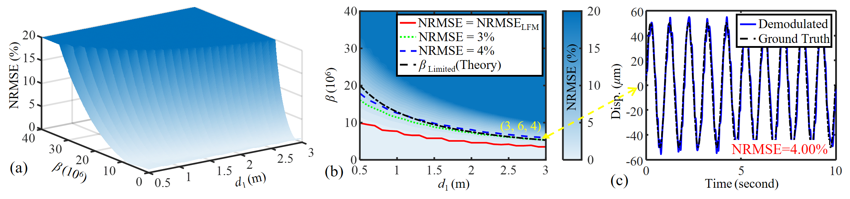

**Fig. 5.** Simulation validation for the “*Multiple Moving Scatterers Coexist*” scenario: (a) simulated normalized root mean square error (NRMSE) between the demodulated target displacement and ground truth under different NLFM amplitude *β*, (b) *xoy* projection of the 3D surface from (a), and simulated NRMSE with the NLFM amplitude *β* set to thetheoretical *βLimited*, and (c) an example of demodulated displacement with an NRMSE of 4.00% in (b).

With a compact size of only 1.74×2.91 cm, nearly equivalent to a coin as in Fig. 6, the radar system benefits from the validated open-loop architecture. This architecture doesn't require PLL, loop filters and reference clock for PLL, thus significantly reducing system complexity.Consequently, this open-loop FMCW radar architecture is very suitable for low-complexity, low-cost, and miniaturized radar applications.

After the radar system is designed, it is necessary to determine the DAC output voltage. First, the F-V curve of the VCO is obtained over the 119 GHz to 119.8 GHz range. This response can be approximated as



Here, *f* = Φ(*v*) represents the response frequency of the VCO, in GHz, and *v* is the input voltage to the VCO, in V

In the experiments described in this paper, the FMCW radar waveform is configured with an initial frequency of 119 GHz, a bandwidth of 0.8 GHz, a ramp-up time of 6 ms, and a pulse repetition time of 10 ms. If a sawtooth waveform is directly applied to drive the VCO [32], the instantaneous frequency expression of the output signal is



where *f* is in GHz. From (33), it is evident that directly driving the VCO with a sawtooth waveform results in severe sinusoidal NLFM, with a modulation amplitude of *β* = 0.190×109 and a frequency of *fnon* = 73.24 Hz. In contrast, the DAC-driven open-loop FMCW radar architecture validated in this paper derives the VCO for LFM based on Φ(*v*). The driving voltage output by the DAC is



Additionally, to facilitate subsequent experiments, an integrated radar systems was designed and fabricated based on the TRX_120_001 transceiver chip, as shown in Fig. 7(a) and 7(b). The PCB consists of two parts: an RF board and a baseband (BB) board, each can be powered independently. In addition to the validated open-loop architecture, the system integrates the other four common radar architectures, including PLL-FMCW, Sawtooth-FMCW, PLL-CW, and Voltage-CW, and enables rapid switching and testing of different architectures through functional selection. The PLL is realized using ADF4159 chip All radar architectures utilize the same transceiver chip and similar baseband circuits to ensure consistency in experimental conditions.

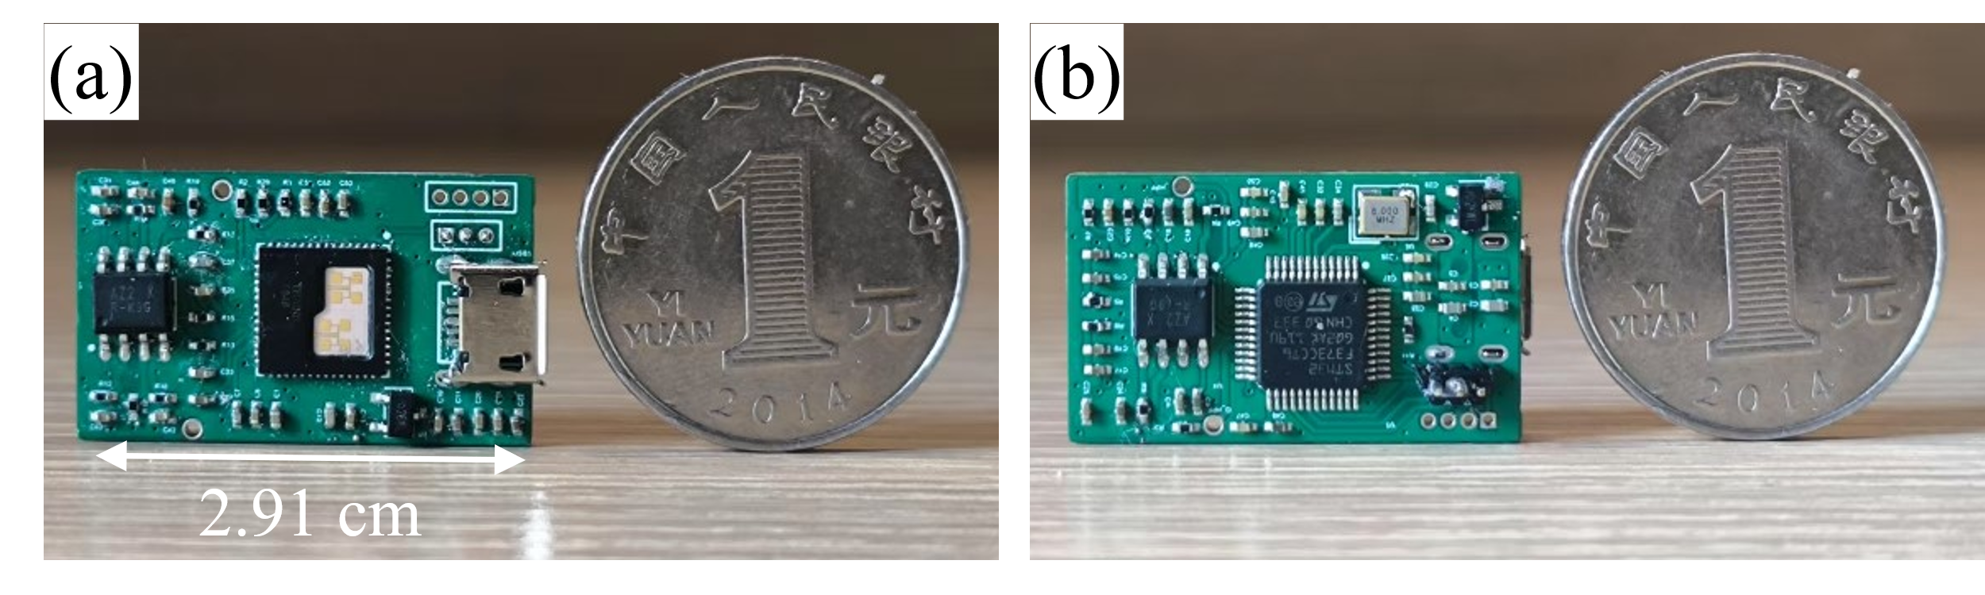

**Fig. 6.** Top (a) and bottom (b) views of custom-designed radar system prototype based on the used open-loop architecture.

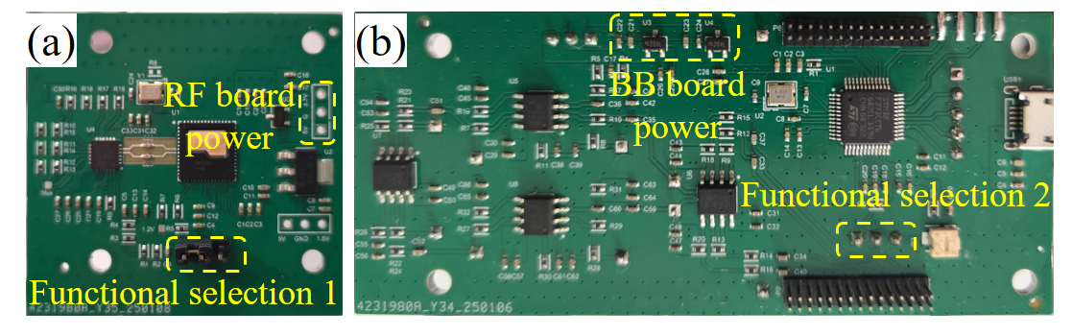

**Fig. 7.** RF board (a) and BB board (b) of custom-designed integrated radar systems. RF: radio frequency; BB: baseband.



**Fig. 8.** Experimental setup for linear stage motion detection.

## B. Validation of Theoretical NLFM Analysis on Displacement Motion Sensing

To validate the theoretical analysis of NLFM on displacement sensing in FMCW radar, we conducted motion-detection experiments based on standard linear stages with varying the sinusoidal NLFM amplitudes *β*.

As described in Section III-A, the FMCW chirp waveform is configured with an initial frequency of 119 GHz, a pulse repetition time of 10 ms, and a ramp-up time of 6 ms. Its instantaneous frequency during ramp-up is given by



where *f* is in GHz, the frequency *fnon* of sinusoidal NLFM is set to 150 Hz. From the obtained VCO’s F-V curve in (32), the required DAC voltage waveforms



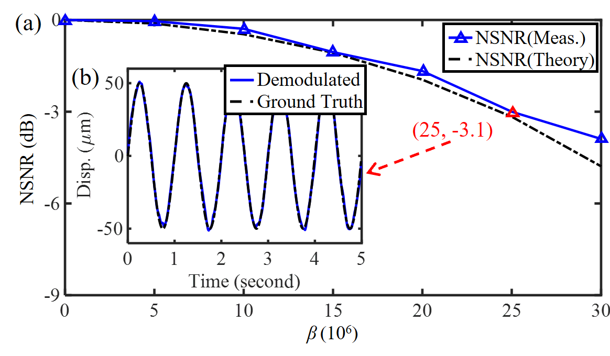

**Fig.9.** Experimental validation for the theoretical analysis in the "*Moving Target with Stationary Scatterers*" scenario: (a) comparison between the theoretically calculated and the measured NSNR of demodulated displacement under different NLFM amplitude *β*, (b) demodulated displacement under *β* = 25×106; Meas.: Measured.

can be determined for each NLFM amplitude *β*. These waveforms are output by the DAC to drive the VCO, thereby producing chirp signals with the specified NLFM amplitudes *β*. Changing *β* only requires the MCU to control the DAC output, without the need to alter the experimental conditions, such as the moving of the radar or linear stages. As a result, the radar, target, and surrounding environment can keep unchanged throughout the experiments, ensuring consistency in experimental conditions.

The experiments were carried out in a typical office environment, as shown in Fig. 8. Linear stage 1 (Zaber X-LDM060C-AE54D12) is positioned 1.1 meters from the radar and performs sinusoidal motion with a frequency of 1 Hz and an amplitude of 50 *μ*m (1/50 λ @ 120 GHz), as the target. Linear stage 2 (LHA4572) is located 1.8 meters from the radar as the strongest scatterer, located closest to the target.

To validate the theoretical analysis, we conducted separate experiments for the two displacement motion sensing scenarios defined in Section II.

*1) Moving Target with Stationary Scatterers:* In this scenario, all scatterers except the target remain stationary. Therefore, in this experiment, linear stage 2 keeps stationary.

*β* was varied from 0 to 30×106 in steps of 5×106. The experimental results are shown in Fig. 9. The measured NSNR of demodulated displacement follows the same trend as the theoretical calculation in (16), with the two curves being with good agreement, thereby validating the accuracy of the theoretical model. According to (19), the theoretical *β*-3*dB* is



As in Fig. 9(a), for *β* = 25×106, the demodulated displacement has an NSNR of -3.1 dB, very close to the theoretical 3 dB decrease expectation. Fig. 9(b) further illustrates that, at *β* = 25×106, the demodulated displacement closely matches the ground truth, accurately recovering the target's motion, thereby confirming the accuracy of the theoretical linearity requirements.

*2) Multiple Moving Scatterers Coexist:* In this experiment, linear stage 2 performs reciprocating linear motion with a speed of 0.5 cm/s over a 2 cm (8 λ @ 120 GHz) range. According to (27), the theoretical *βLimited* for accuracy motion sensing is

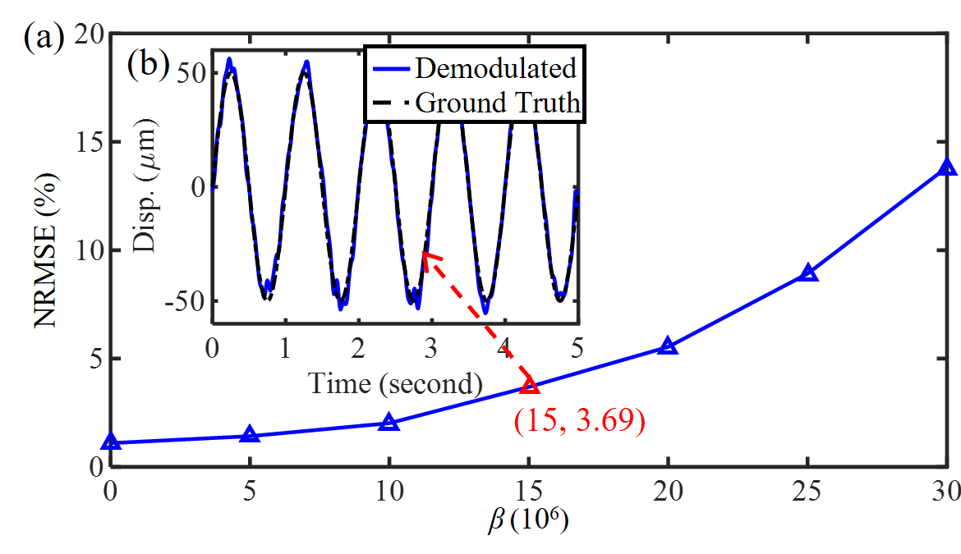

**Fig. 10.** Experimental validation for the theoretical analysis in the "*Multiple Moving Scatterers Coexist*" scenario: (a) measured NRMSE between demodulated displacement and ground truth under different NLFM amplitude *β*, (b) demodulated displacement under *β* = 15×106.



Based on the simulation results in Section III-B, when *β* = *βLimited*, the NRMSE of the demodulated displacement is approximately 3% - 4%.

In the experiment, *β* was varied from 0 to 30×106 in steps of 5×106. The experimental results are shown in Fig. 10(a), where for *β* = 15×106, the NRMSE of the demodulated displacement is 3.69%, which closely matches the simulation results (3% - 4%). As shown in Fig. 10(b), the demodulated displacement under *β* = 15×106 aligns very well with the ground truth, demonstrating the ability to accurately recover the target's displacement. These experimental results validate that accuracy motion sensing of the target can be achieved under the theoretically calculated *βLimited*, confirming the accuracy of the theoretical model and analysis.

## C. Performance Comparison of Five Radar Architectures

The motion sensing performance of the validated open-loop architecture was compared with that of four existing architectures: PLL-FMCW, Sawtooth-FMCW, PLL-CW, and Voltage-CW, using the fabricated integrated radar system as shown in Fig. 7. The experimental setup remains as in Fig. 8.

*1) Moving Target with Stationary Scatterers:* In this scenario, linear stage 1 performs sinusoidal motion with a frequency of 1 Hz and an amplitude of 50 *μ*m. Linear stage 2 keeps stationary.

The results of circle fitting and demodulated displacement for the five radar architectures are shown in Fig. 11. Comparing Fig. 11(a) - (c) with Fig. 11(d) and 11(e), it can be observed that the SNR of the extracted *I/Q* signals and demodulated displacements for the three FMCW radar architectures is significantly higher than that of the two CW radar architectures. Additionally, the NRMSE of the demodulated displacement for the FMCW radar architectures is noticeably lower compared to the CW radar architectures, with the NRMSE of the FMCW radar architectures being approximately 2%, while the NRMSE for the CW radar architectures is around 29%. These results demonstrate that the FMCW radar architectures significantly outperform the CW radar architectures in terms of motion sensing capability.

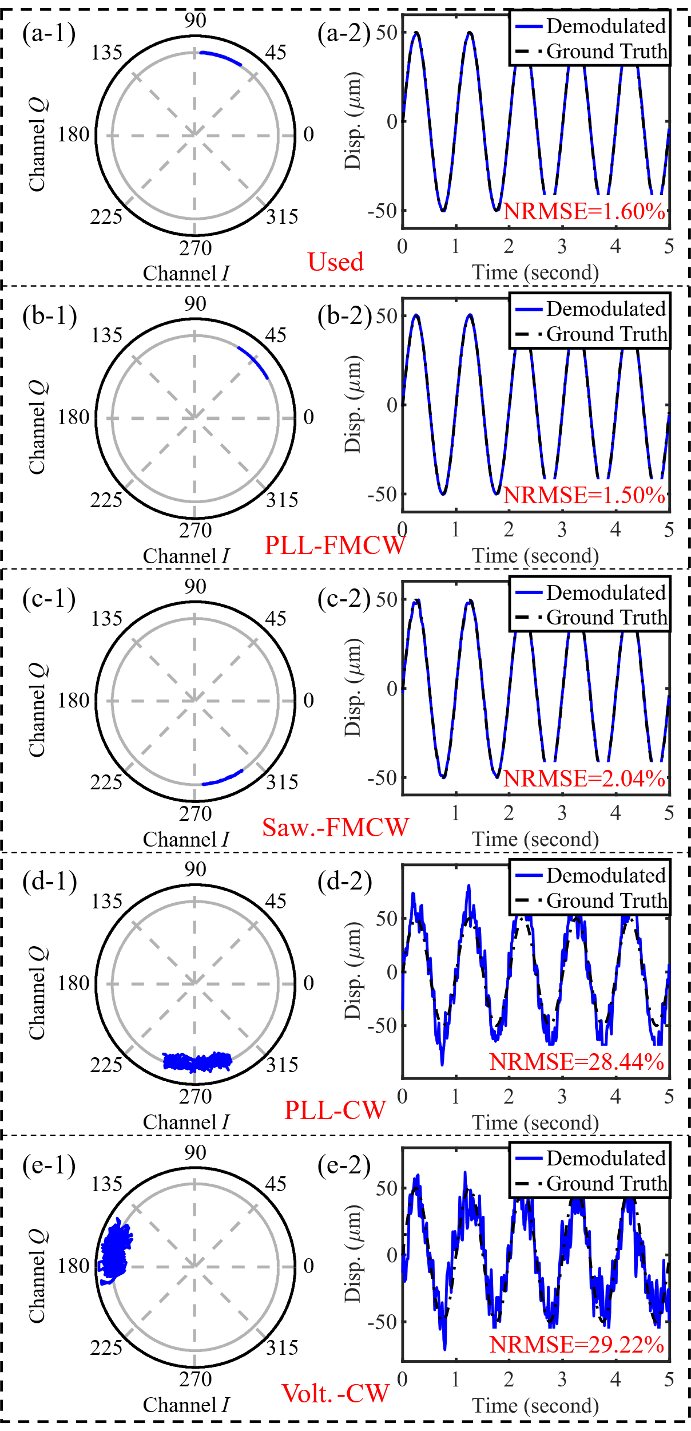

**Fig. 11.** The motion sensing results in the “*Moving Target with Stationary Scatterers*” scenario of the five radar architectures: (a)-(e) experimental results for the validated, PLL-FMCW, Saw.-FMCW, PLL-CW, and Volt.-CW architectures. In each row, (1) the circle fitting results of the extracted *I/Q* signals, and (2) the demodulated displacement.

TABLE I

Motion Sensing Performance Comparison of Five Radar Architectures in the Scenario I

|  |  |  |  |  |  |
| --- | --- | --- | --- | --- | --- |
| **GT/*μ*m** | **NRMSE/%**  **(#1)** | **NRMSE/%**  **(#2)** | **NRMSE/%**  **(#3)** | **NRMSE/%**  **(#4)** | **NRMSE/%**  **(#5)** |
| 5 | 14.39 | 13.60 | 15.42 | \ | \ |
| 10 | 6.15 | 4.32 | 6.48 | \ | \ |
| 20 | 2.75 | 3.50 | 4.17 | \ | \ |
| 50 | 1.60 | 1.50 | 2.04 | 28.44 | 29.22 |
| 200 | 0.86 | 1.02 | 1.58 | 13.93 | 19.87 |

Scenario I: “*Moving Target with Stationary Scatterers*” scenario; GT: ground truth; #1: validated FMCW architecture; #2: PLL-FMCW; #3: Sawtooth-FMCW; #4: PLL-CW; #5: Voltage-CW.

Comparing the circle fitting results for the three FMCW architectures, it is evident that all three produce highly accurate fitting results. Further analysis of the demodulated displacement shows that both the validated FMCW radar architecture and the PLL-FMCW architecture exhibit close alignment with the ground truth, with the NRMSE values of 1.60% and 1.50%, respectively. In contrast, the Sawtooth-FMCW radar architecture exhibits more noise fluctuations in its demodulated displacement, with its NRMSE slightly higher at 2.04%. Nonetheless, it still provides an accurate recovery of the target's displacement.

To provide a more comprehensive comparison of the motion sensing performance of the five architectures, a series of experiments with different displacements were conducted, and the results are summarized in Table I. From the results in Table I, it can be observed that, in the “*Moving Target with Stationary Scatterers*” scenario, the NRMSE for the validated radar architecture is almost identical to that of the PLL-FMCW architecture and slightly better than the Sawtooth-FMCW architecture across different displacements. In contrast, the two CW radar architectures can only detect displacements with amplitudes larger than 50 *μ*m, with their NRMSE significantly higher than that of the three FMCW radar architectures. When comparing the two CW architectures, the PLL-CW architecture demonstrates a lower NRMSE, indicating better motion-sensing performance.

All of the above results indicate that the validated FMCW radar architecture effectively mitigates the NLFM, with performance nearly matching that of the closed-loop PLL-FMCW architecture. Even in the Sawtooth-FMCW radar architecture, which suffers from significant NLFM, *β* = 0.190×109, accurate motion recovery is still possible. This validates that displacement motion sensing has strong robustness against NLFM in “*Moving Target with Stationary Scatterers*” scenario. Additionally, the motion sensing performance of the FMCW radar architectures significantly outperforms that of the CW radar, and the PLL-CW architecture is better than the Voltage-CW architecture.

*2) Multiple Moving Scatterers Coexist:* Linear stage 1 still undergoes sinusoidal motion at a frequency of 1 Hz and an amplitude of 50 *µ*m. Linear stage 2 performs reciprocating linear motion with a speed of 0.5 cm/s over a 2 cm (8 λ @ 120 GHz) range. The experimental results are shown in Fig. 12. Since CW radar cannot detect multiple moving scatterers, this experiment only compares the performance of the three FMCW radar architectures.

As shown in Fig. 12, both the validated and the PLL- FMCW architecture are capable of accurately detecting the target's motion, with NRMSE both being less than 3%. However, the motion demodulated by the Sawtooth-FMCW architecture shows significant deviation from the ground truth, with an NRMSE exceeding 200%, indicating complete demodulation failure in this scenario.

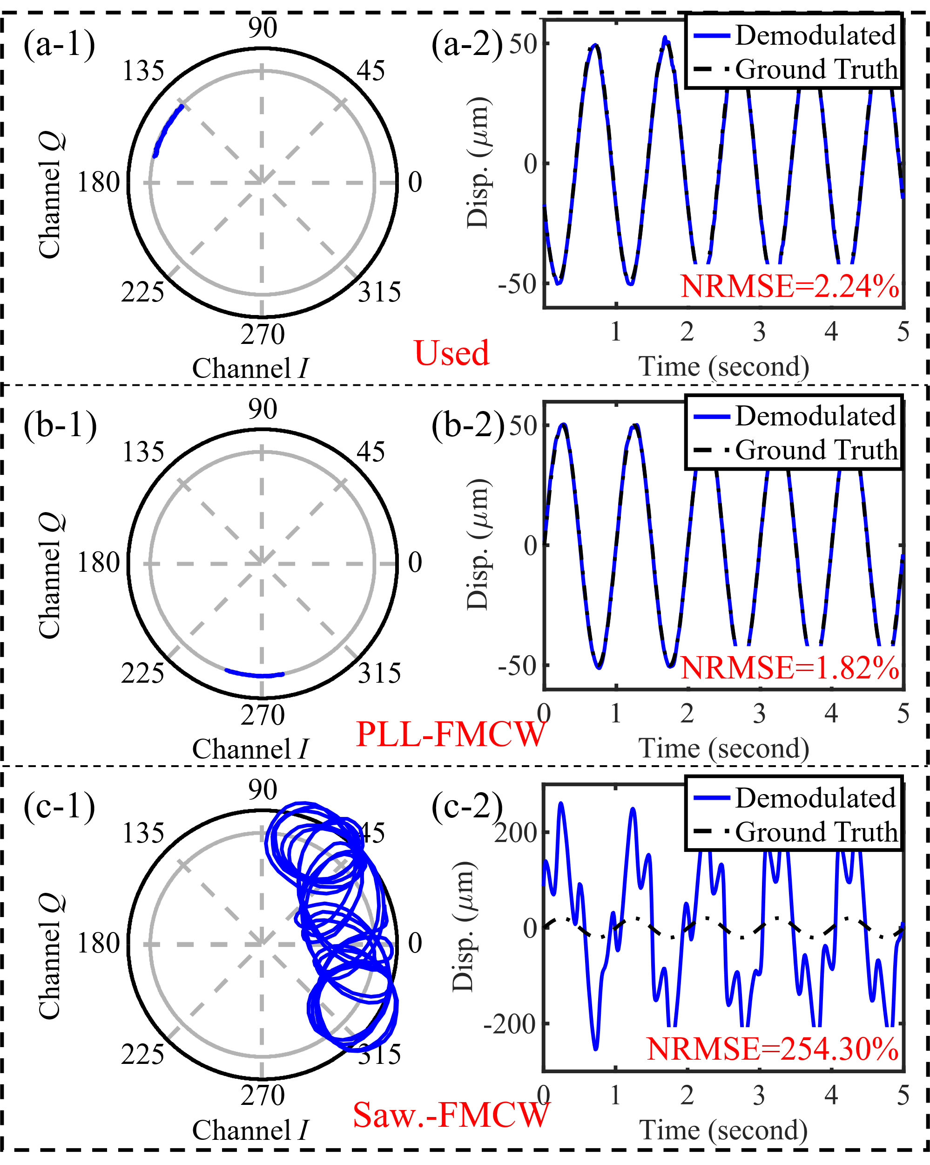

**Fig. 12.** The motion sensing results in the “*Multiple Moving Scatterers Coexist*” scenario of three FMCW radar architectures: (a)-(c) experimental results for the validated, PLL-FMCW, and Saw.-FMCW architectures. In each row, (1) the circle fitting results of the extracted *I/Q* signals, and (2) the demodulated displacement.

Based on the theoretical derivation (27) in Section II-B, to accurately extract the target's motion, the *β*-3*dB* is:



However, the amplitude *β* of the sinusoidal NLFM in the Sawtooth-FMCW architecture is 0.190×109, which far exceeds *βLimited*. As a result, the extracted *I/Q* signal is severely coupled with the motion of linear stage 2, leading to complete failure of both the circle fitting and displacement demodulation, as shown in Fig. 12(c).

From the above experimental results, it can be seen that, in “*Multiple Moving Scatterers Coexist*” scenario, the validated architecture still achieves motion-sensing performance nearly identical to that of the closed-loop PLL-FMCW architecture.

## D. Robustness of the Validated Architecture

In this section, experiments are conducted to evaluate the motion sensing performance of the validated architecture under different VCO supply voltages and temperatures.

The experimental setup remains as shown in Fig. 8. Linear stage 1 performs sinusoidal motion with an amplitude of 50 *μ*m and a frequency of 1 Hz as the target. Linear stage 2 is still located at 1.8 m from the radar. In "*Moving Target with Stationary Scatterers*" scenario, linear stage 2 remains stationary, while in "*Multiple Moving Scatterers Coexist*" scenario, it undergoes reciprocating linear motion with a speed of 0.5 cm/s over a 2 cm range.

*1) VCO Power Supply Changes:* In this experiment, the DAC output, when the VCO power supply is 3.3V, is capable of driving the VCO to generate a linear frequency-modulated chirp signal. the DAC output is configured to drive the VCO, generating LFM chirp signal with a VCO power supply of 3.3 V. The DAC output remains unchanged during the experiment, while the VCO power supply is varied from 3.1 V to 3.5 V to assess the architecture's motion sensing performance in both scenarios.

The experimental results are shown in Fig. 13. When the VCO power supply is 3.1 V, the NRMSE of the demodulated target displacement is largest in both scenarios, with values of 1.89% and 2.87%, respectively. Although the NRMSE is higher compared to the 3.3 V supply voltage, it remains below 3%, indicating that accuracy motion sensing can still be achieved. These results confirm that the validated open-loop architecture exhibits good robustness to changes in the VCO power supply for displacement motion sensing.

*2) VCO Temperature Changes:* In this experiment, the DAC output, when the temperature of VCO chip is 39.8°C, is capable of driving the VCO to generate a linear frequency-modulated chirp signal. We used an infrared thermometer (HT3201) to monitor the temperature variation of the VCO chip and demodulated the target’s displacement using the open-loop architecture at different moments after power-up. The results are summarized in Table II.

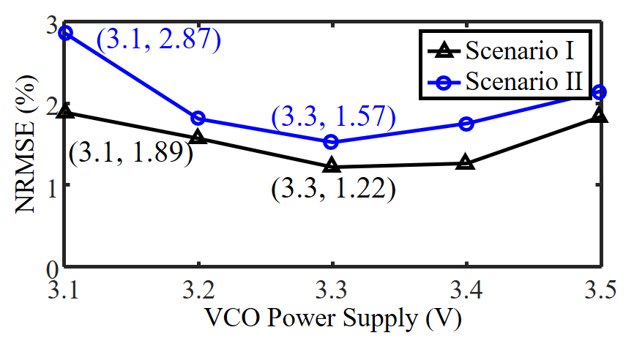

**Fig. 13.** Measured NRMSE of demodulated displacement with varying VCO power supply. Scenario I: "*Moving Target with Stationary Scatterers*" scenario; Scenario II: "*Multiple Moving Scatterers Coexist*" scenario.

TABLE II

Measured NRMSE of Demodulated Displacement with Different VCO Temperature

|  |  |  |  |
| --- | --- | --- | --- |
| **Time / Minute** | **Temperature / ℃** | **NRMSE/% (#1)** | **NRMSE/% (#2)** |
| 1 | 30.3 | 1.87 | 3.12 |
| 2 | 35.6 | 1.69 | 2.19 |
| 3 | 36.8 | 1.57 | 1.95 |
| 4 | 38.2 | 1.45 | 1.77 |
| 7 | 39.2 | 1.32 | 1.65 |
| 9 | 39.8 | 1.29 | 1.60 |

#1: "*Moving Target with Stationary Scatterers*" scenario; #2: "*Multiple Moving Scatterers Coexist*" scenario.

As shown in Table II, the chip's temperature is 30.3°C after 1 minute of power-up, and it stabilizes at 39.8°C after 9 minutes, at which point the VCO outputs the linear frequency-modulated signal. After 1 minute of power-up, the NRMSE of the demodulated displacement is highest in both scenarios, with values of 1.87% and 3.12%, respectively, with minimal error compared to the ground truth, still enabling accurate displacement motion sensing. These experimental results demonstrate that, even with a temperature deviation of 9.5°C, the open-loop architecture can still accurately sense the target's displacement motion, confirming its robustness to temperature variations.

## E. Multi-person Cardiogram Monitoring

The experimental setup for multi-person cardiogram monitoring is shown in Fig. 14(a). Subjects 1 and 2 remain stationary at distances of 0.6 meters and 1.2 meters from the radar, respectively, while breathing uniformly. Both subjects are equipped with electrocardiogram (ECG) devices based on the AD8232 chip, as references for the monitored cardiograms. The radar used in this experiment is the miniaturized radar based on the validated architecture as shown in Fig. 6.

The radar’s beat signals and the outputs of the two ECG devices are synchronously sampled using the ADC module integrated in the MCU. The Hamming window is applied to the beat signal, followed by Fourier transformation to extract the *I/Q* signals from the respective range bins of subjects 1 and 2. These *I/Q* signals are DC-calibrated and phase-demodulated to obtain the chest displacements of two subjects. A FIR high-pass filter with a cutoff frequency of 0.9 Hz and a stopband attenuation of 50 dB is applied to these displacements. The filtered displacements are then differentiated to obtain the differential microwave cardiogram (D-MCG). Finally, the extracted D-MCG and synchronized ECG reference are transferred via UART to a PC for recording and analysis.

As shown in Fig. 14(b) and 14(c), the D-MCG results detected for both subjects are in excellent agreement with the reference ECG signal, demonstrating the validated radar’s capability to accurately detect human cardiac activity. The radar, operating in the sub-terahertz frequency, benefits from the short wavelength, making it more sensitive to phase changes. The D-MCG results from both subjects provide more detailed cardiac activity information, highlighting the radar’s potential for non-contact cardiac disease diagnosis, which shows significant promise compared to existing systems in the V and K bands [33], [34]. Furthermore, the radar, based on the validated architecture, is coin-sized yet capable of high-precision motion monitoring. It provides advantages in miniaturization, low cost, low complexity, and portability, indicating its strong potential for wide-ranging applications.

# V. Conclusion

This paper presents a comprehensive theoretical analysis of the impact of NLFM on displacement motion sensing in FMCW radar. The derivation demonstrates that displacement motion sensing exhibits robustness to NLFM. Further, the linearity requirements for accurate motion extraction are also derived, providing theoretical guidance for the FMCW radar applications. Both simulation and experimental results are in good agreement with the theoretical predictions. Furthermore, a novel low-complexity open-loop FMCW radar architecture is validated for meeting linearity requirements for accurate motion sensing without relying on any reference target. Experimental results demonstrate that the validated architecture achieves motion sensing accuracy comparable to that of the closed-loop PLL-FMCW architecture while maintaining a low hardware complexity similar to that of the open-loop Voltage-CW architecture. Finally, A miniaturized radar prototype based on the validated architecture also achieves accurate D-MCG results highly consistent with ECG in multi-person cardiogram monitoring experiments, confirming its potential for low-cost, low-complexity, high-accuracy, and compact short-range radar applications.

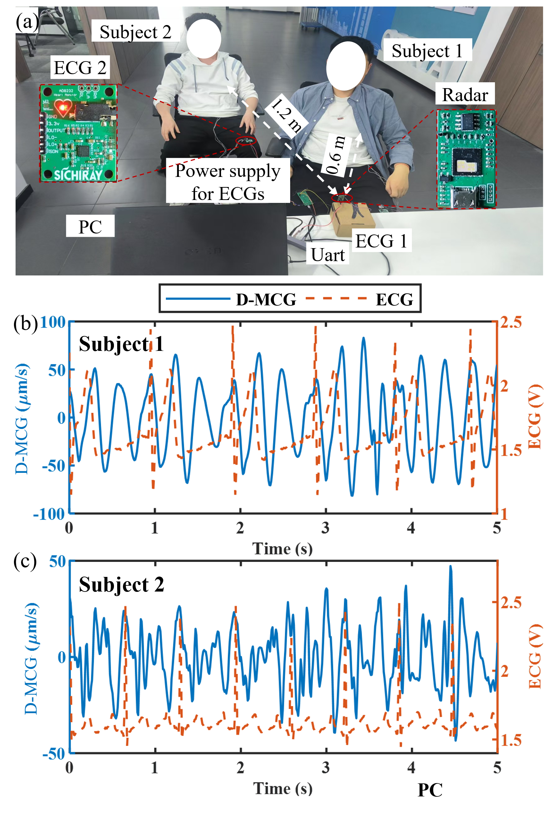

**Fig. 14.** Multi-person cardiogram monitoring experiment: (a) setup, (b) detected D-MCG and reference ECG of subject 1, and (c) detected D-MCG and reference ECG of subject 2.

References

1. C. Feng et al., "Multitarget Vital Signs Measurement With Chest Motion Imaging Based on MIMO Radar," in *IEEE Trans. Microw. Theory Techn.*, vol. 69, no. 11, pp. 4735-4747, Nov. 2021.
2. Y. Li, C. Gu and J. Mao, "A Robust and Accurate FMCW MIMO Radar Vital Sign Monitoring Framework With 4-D Cardiac Beamformer and Heart-Rate Trace Carving Technique," in *IEEE Trans. Microw. Theory Techn.*, vol. 72, no. 10, pp. 6094-6106, Oct. 2024.
3. J. Xiong, H. Hong, L. Xiao, E. Wang, and X. Zhu, "Vital Signs Detection With Difference Beamforming and Orthogonal Projection Filter Based on SIMO-FMCW Radar," in *IEEE Trans. Microw. Theory Techn.*, vol. 71, no. 1, pp. 83-92, Jan. 2023, doi: 10.1109/TMTT.2022.3181129.
4. M. He, X. Yang, C. -H. Fu, L. Zhang and H. Hong, "FMCW Radar Vibration Measurement Using Sub-Chirp Group Multicircle Fitting With PCA-Based Solution Space Constraints," in *IEEE Trans. Microw. Theory Techn.*, vol. 73, no. 3, pp. 1329-1344, March 2025.
5. A. A. Pramudita, D. -B. Lin, A. A. Dhiyani, H. H. Ryanu, T. Adiprabowo and E. A. Yudha, "FMCW Radar for Noncontact Bridge Structure Displacement Estimation," in *IEEE Trans. Instrum. Meas.*, vol. 72, pp. 1-14, 2023.
6. Z. Zhang, J. Zhang, J. Liu, Y. Li and C. Gu, "Enhanced Motion Sensing With FMCW Radar Based on a Novel Frequency-Reconfigurable Technique," in *IEEE Trans. Microw. Theory Techn.*, vol. 72, no. 10, pp. 6187-6199, Oct. 2024.
7. T. Stadelmayer, A. Santra, R. Weigel and F. Lurz, "Radar-Based Gesture Recognition Using a Variational Autoencoder With Deep Statistical Metric Learning," in *IEEE Trans. Microw. Theory Techn.*, vol. 70, no. 11, pp. 5051-5062, Nov. 2022.
8. R. Zheng, C. Wang, X. He and X. Li, "A Correction Method for the Nonlinearity of FMCW Radar Sensors Based on Multisynchrosqueezing Transform," in *IEEE Sensors J.*, vol. 23, no. 1, pp. 609-619, 1 Jan.1, 2023.
9. S. O. Piper, "Homodyne FMCW radar range resolution effects with sinusoidal nonlinearities in the frequency sweep," in *Proc. Int. Radar Conf.*, Alexandria, VA, USA, 1995, pp. 563-567.
10. M. Pichler, A. Stelzer, P. Gulden and M. Vossiek, "Influence of Systematic Frequency-Sweep Non-Linearity on Object Distance Estimation in FMCW/FSCW Radar Systems," In *Proc. 33rd Eur. Microw. Conf.*, Munich, Germany, 2003, pp. 1203-1206.
11. S. Scheiblhofer, S. Schuster and A. Stelzer, "Signal model and linearization for nonlinear chirps in FMCW Radar SAW-ID tag request," in *IEEE Trans. Microw. Theory Techn.*, vol. 54, no. 4, pp. 1477-1483, June 2006.
12. A. Meta, P. Hoogeboom and L. P. Ligthart, "Signal Processing for FMCW SAR," in IEEE *Trans. Geosci. Remote Sens*., vol. 45, no. 11, pp. 3519-3532, Nov. 2007.
13. C. Gu, Z. Zhang, J. Liu and J. Mao, "Characterization of the Frequency Ramp Nonlinearity Impact on the Range Estimation Accuracy and Resolution in LFMCW Radars," in *IEEE Trans. Instrum. Meas.*, vol. 72, pp. 1-12, 2023, Art no. 8003712.
14. T. Mitomo, N. Ono, H. Hoshino, Y. Yoshihara, O. Watanabe, and I. Seto, “A 77 GHz 90 nm CMOS transceiver for FMCW radar applications,” *IEEE J. Solid-State Circuits*, vol. 45, no. 4, pp. 928–937, Apr. 2010.
15. A. Frischen, J. Hasch, and C. Waldschmidt, “FMCW ramp non-linearity effects and measurement technique for cooperative radar,” in *Proc. Eur. Radar Conf. (EuRAD)*, Sep. 2015, pp. 509–512.
16. N. Pohl, T. Jaeschke and K. Aufinger, "An Ultra-Wideband 80 GHz FMCW Radar System Using a SiGe Bipolar Transceiver Chip Stabilized by a Fractional-N PLL Synthesizer," in *IEEE Trans. Microw. Theory Techn.*, vol. 60, no. 3, pp. 757-765, March 2012.
17. S. Scheiblhofer, S. Schuster and A. Stelzer, "High-Speed FMCW Radar Frequency Synthesizer With DDS Based Linearization," in *IEEE Microw. and Wireless Compon. Lett.*, vol. 17, no. 5, pp. 397-399, May 2007.
18. D. Gomez-Garcia, C. Leuschen, F. Rodriguez-Morales, J.-B. Yan, and P. Gogineni, “Linear chirp generator based on direct digital synthesis and frequency multiplication for airborne FMCW snow probing radar,” in *IEEE MTT-S Int. Microw. Symp. Dig*., Jun. 2014, pp. 1–4.
19. P. J. Burke, "Ultra-linear chirp generation via VCO tuning predistortion," in *IEEE MTT-S Int. Microw. Symp. Dig.*, May 1994, pp. 957–960.
20. M. Z. Straayer, A. V. Messier and W. G. Lyons, "Ultra-Linear Superwideband Chirp Generator using Digital Compensation," in *IEEE MTT-S Int. Microw. Symp. Dig.*, Jun. 2006, pp. 403–406.
21. A. Anghel, G. Vasile, R. Cacoveanu, C. Ioana, and S. Ciochina, “Short-range wideband FMCW radar for millimetric displacement measurements,” in *IEEE Trans. Geosci. Remote Sens.,* vol. 52, no. 9, pp. 5633–5642, Sep. 2014.
22. R. Zheng, C. Wang, X. He and X. Li, "A Correction Method for the Nonlinearity of FMCW Radar Sensors Based on Multisynchrosqueezing Transform," in *IEEE Sensors J.*, vol. 23, no. 1, pp. 609-619, 1 Jan.1, 2023
23. R. Zheng, J. Zhu, C. Wang and X. Li, "An Improved HAF-Based Nonlinear Correction Method of FMCW Radar With CEEMD," in *IEEE Trans. Instrum. Meas.*, vol. 72, pp. 1-10, 2023.
24. B. Wang, T. Lai, H. Huang and Q. Wang, "A Nonlinear Phase Compensation Method for FMCW Radar Based on VNCMD," in *IEEE Sensors J.*, vol. 24, no. 21, pp. 35156-35166, 1 Nov.1, 2024
25. S. E. Sorkhabi, R. Feghhi, A. Lim and K. Rambabu, "Nonlinearity-Compensated Short-Range FMCW Radar for Weak Target Imaging," in *IEEE Trans. Microw. Theory Techn.*, vol. 71, no. 5, pp. 2245-2257, May 2023
26. M. Vasconcelos, P. Nallabolu and C. Li, "Range Resolution Improvement in FMCW Radar Through VCO's Nonlinearity Compensation," in *Proc. IEEE Top. Conf. Wireless Sensors Sensor Netw.*, Las Vegas, NV, USA, 2023, pp. 53-56.
27. P. V. Brennan, Y. Huang, M. Ash and K. Chetty, "Determination of Sweep Linearity Requirements in FMCW Radar Systems Based on Simple Voltage-Controlled Oscillator Sources," in *IEEE Trans. Aerosp. Electron. Syst.*, vol. 47, no. 3, pp. 1594-1604, July 2011.
28. W. G. Carrara, R. S. Goodman, and R. M. Majewski, *Spotlight Synthetic Aperture Radar: Signal Processing Algorithms*. Boston, MA, USA: Artech House, 1995
29. J. Liu, Y. Li, C. Li, C. Gu and J. -F. Mao, "Accurate Measurement of Human Vital Signs With Linear FMCW Radars Under Proximity Stationary Clutters," in *IEEE Trans. Biomed. Circuits Syst.*, vol. 15, no. 6, pp. 1393-1404, Dec. 2021.
30. S. Guan, J. A. Rice, C. Li and C. Gu, "Automated DC Offset Calibration Strategy for Structural Health Monitoring Based on Portable CW Radar Sensor," in *IEEE Trans. Instrum. Meas.*, vol. 63, no. 12, pp. 3111-3118, Dec. 2014
31. W. Xu, Y. Li, C. Gu, and J.-F. Mao, "Large Displacement Motion Interferometry With Modified Differentiate and Cross-Multiply Technique," in *IEEE Trans. Microw. Theory Techn*., vol. 69, no. 11, pp. 4879–4890, Nov. 2021.
32. A. Tessmann, S. Kudszus, T. Feltgen, M. Riessle, C. Sklarczyk and W. H. Haydl, "Compact single-chip W-band FMCW radar modules for commercial high-resolution sensor applications," in *IEEE Trans. Microw. Theory Techn*., vol. 50, no. 12, pp. 2995-3001, Dec. 2002.
33. C. Zhu et al., "Doppler Cardiogram Detected by a V-Band Doppler Radar Sensor," in *IEEE Trans. Microw. Theory Techn*., vol. 70, no. 1, pp. 521-531, Jan. 2022.
34. S. Dong, Y. Li, J. Lu, Z. Zhang, C. Gu and J. Mao, "Accurate Detection of Doppler Cardiograms With a Parameterized Respiratory Filter Technique Using a K-Band Radar Sensor," in *IEEE Trans. Microw. Theory Techn*., vol. 71, no. 1, pp. 71-82, Jan. 2023.

1. Manuscript received January 15, 2024; revised February 28, 2024; accepted March 22, 2024. This work was supported in part by the Shanghai Science and Technology Funds under Grant 24YL1900600. *(Corresponding author: Changzhan Gu.)*

   The authors are with the State Key Laboratory of Radio Frequency Heterogeneous Integration (Shanghai Jiao Tong University), Shanghai Jiao Tong University, Shanghai 200240, China (e-mail: changzhan@sjtu.edu.cn).

   Color versions of one or more figures in this article are available at https://doi.org/.

   Digital Object Identifier

   555555555555555